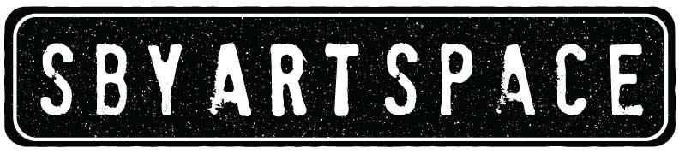
Salisbury Art Space, 212 West Main Street, Suite 101, Salisbury, MD 21801
410-546-4748 | www.SalisburyArtSpace.org |Salisburyartspaceinfo@gmail.com

Common Objects
Prospectus and Call for Entry
Exhibition dates: March 4th, 2022 – March 31st, 2022

Things are all around us and are fun to explore. What do you consider a “common object”?

This exhibition is open to SAS Members and Non-members. Open to all themes and all media (for specifics, see guidelines).

Important Dates
• February 25 & 26, 12pm-5 pm: Art intake drop off. Call SAS at 410-546-4748 for any questions.
• April 1 & 2, 12pm-5 pm: Art pick up. Schedule an appointment during art intake or call ahead.

Submission Process
• Complete submission form and bring artwork to SAS at scheduled appointment time (see above).
• For label information, create 2 cards with Name, Title of Artwork, Medium, Price or NFS (not for sale) and artist contact Information (phone and email); attach one firmly to the back or base of artwork, the other to the front of artwork.
• If you are not already listed in our artist binder, please email a short bio/artist statement for inclusion to salisburyartspaceinfo@gmail.com , include a photo if possible.
• All 2D artwork must be ready to hang with proper hardware and hanging wire.
• Only original work completed within the last three years, which has not been previously shown at the SAS, will be accepted.

Entry Fees
• $15 per artwork for SAS Artist Members; $20 per artwork for non-members. Artists can join SAS or upgrade membership category to Artist member category at intake.
• Please make checks payable to Salisbury Art Space. Entry fees are non-refundable.
• At least one artwork must be for sale.
• Work valued at over $200 may be sold on a 90-day payment plan to encourage sales.

Artwork Guidelines
- 2D artwork must be smaller than 48”x 48” including frame; 3D work must weigh less than 100 lbs.
- The exhibition is open to all themes and all media of artwork (including drawing, painting, printmaking, photography, ceramics, sculpture and mixed media).
- SAS will retain a 30% commission on artwork sold. A higher rate as a donation is greatly appreciated.
- All 2D art work should be ready to hang with suitable wire. Please no saw tooth hangers. If hanging mechanism is missing or nonfunctional the work will not be hung. Please make sure that your hanging device is securely attached.
- If work requires special installation, please specify at art intake and be available to assist.
- SAS retains the final decision regarding works to be exhibited.

SAS is not responsible for artwork remaining after pick-up dates. Lack of appropriate storage space at SAS may result in damage. Any unsold art left after 30 days without prior arrangements made for pickup will become the property of the SAS and may be sold.

Awards
The artworks will be judged and awards are: 1 Judge’s Choice and 3 Honorable Mentions. Cash prize for Judge’s Choice.

Judges – John Mosher

SAS reserves the right to photograph and reproduce images for publicity purposes. All accepted work must remain in the exhibition for its duration.

Salisbury Art Space, 212 West Main Street, Suite 101, Salisbury, MD 21801
410-546-4748 | www.SalisburyArtSpace.org |Salisburyartspaceinfo@gmail.com

Common Objects | Submission Form
Open to SAS Members & Non-members
Exhibition dates: March 4th, 2022 - March 31st, 2022
Intake: February 24th-25th, 12pm-5 pm

Name:___________________________________ Phone Number: ______________________

Email: ________________________________________________________________________

Entries: Entry fee $15 per artwork for SAS Artist Members.

This form must be submitted with entries and payment. Checks should be payable to SAS.
Title Medium Size Price Year
- _____________________________________________________________________________
- _____________________________________________________________________________
- _____________________________________________________________________________
- _____________________________________________________________________________

☐ Please check if all proceeds to go to SAS as a donation.
Disclaimers: SAS carries insurance up to $30,000.00, collectively. After any claim made, SAS is not responsible for the loss or damage of any artwork. We strongly encourage artists to hold insurance on their artwork against loss or damage. All artwork left at the gallery 30 days past the end of the exhibition will be considered abandoned, becomes the property of SAS and may be sold or destroyed. If you are unable to pick up at the show’s end, please contact us and we will make other arrangements with you. We reserve the right to use our images of your artwork in print, web and social media for the advertising of SAS and the exhibition. By signing this I am agreeing to all terms in the prospectus and call for entry.

Signature: ___________________________________________________ Date: __________
____________Office Use: Payment Amt:____________ Type:___________ Rev’d By:___________ Date: ___________

